EENG 385 - Electronic Devices and Circuits

Audio Board: Power Supply

Assembly Guide

**The gate source voltage is 10.1V – 5.1V = 5V.**

# Soldering Together the Power Subsystem

The Audio board has far fewer resistors than the BJT curve tracer. Even so, it is worth your time to brush-up on how to interpret the resistors color bands of the resistors to be used in this lab.

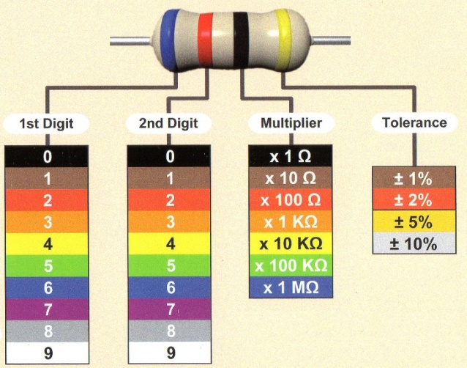

Figure : The colored bands on resistors encode its resistance.

You will be soldering the power subsystem for the Audio board this week using the schematic in Figure 8. On a philosophical note, the schematic shows the logical relationship between parts in a familiar format. When I design a schematic, I try to isolate function units of the design. Then, I connect these functional units together using named wires. Named wires greatly reduce the wiring clutter on the schematic and make the schematic more readable.

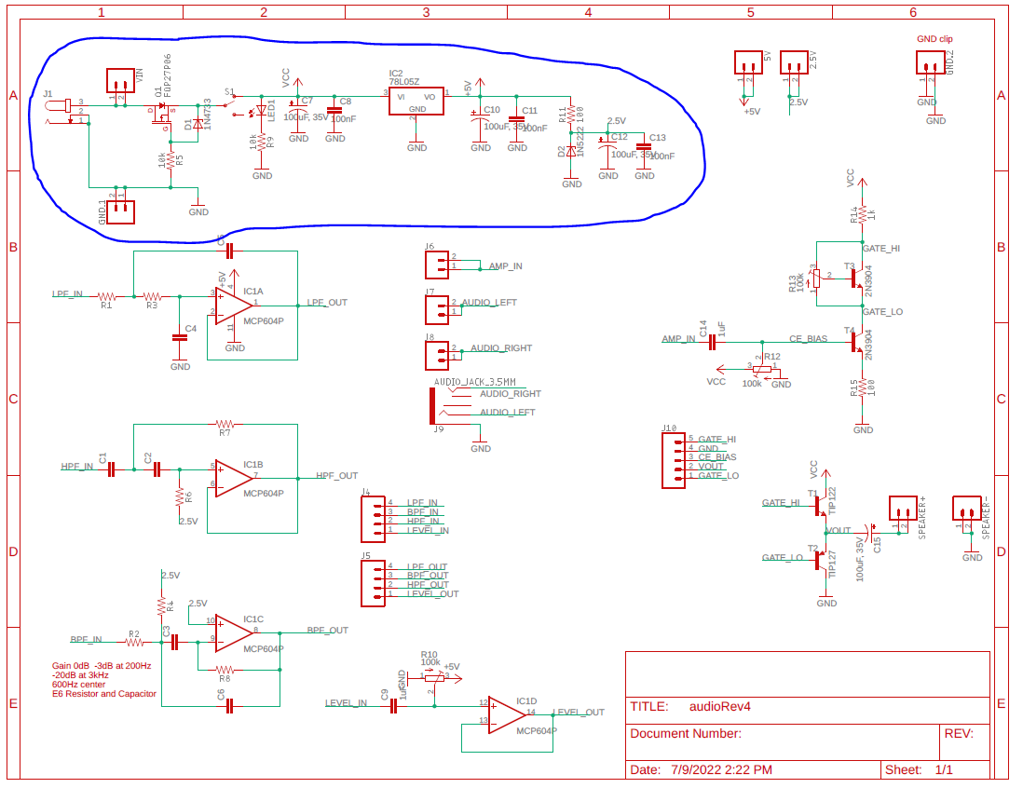

Figure : The schematic for the Audio board with the power subsystem circled in blue.

Like, your previous experiences, the parts in this schematic have a designator and a value. These designators are used to relate a part in the schematic with the layout. I converted the schematic in Figure 8 to the layout shown in Figure 9. As before, the physical position of the parts in the schematic and layout are unrelated, the schematic is an abstraction of the finished layout. The layout contains all the data used in the fabrication of the PCBs – the layout and the fabricated PCB are identical.

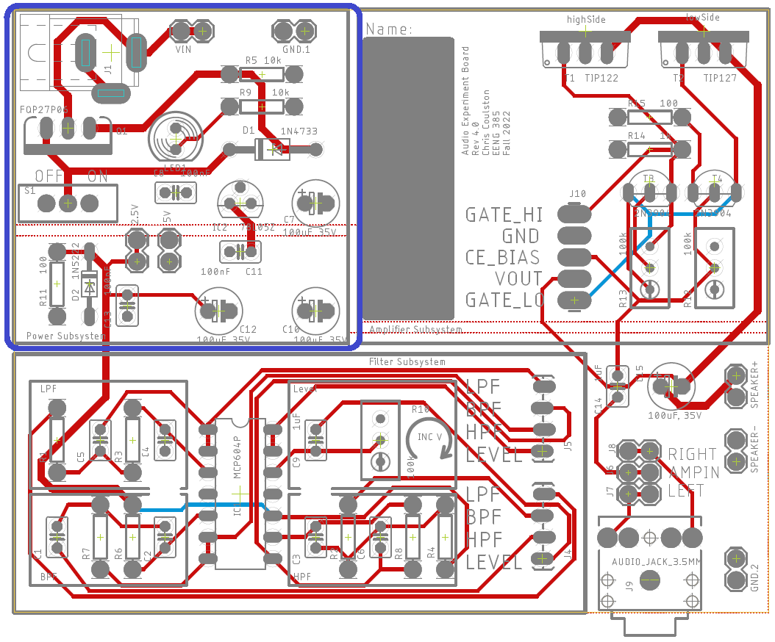

Figure : The layout of the Audio board with the power subsystem outlined in blue.

You should notice parts logically related in the schematic are physically proximal in the layout.

# Polarized Parts

Most of the parts to be soldered into the PCB can be installed in more than one way. Parts which must be installed in a correct orientation are called polarized. Polarized parts have some physical indication of their orientation and the silk screen will have some markings to show you where this physical indicator should be aligned. Let’s walk through all the polarized parts that you will solder this week and how you will install them in the PCB.

* Zener diode 1N5222

This Zener diode is formed from glass with an orange body and a black stripe on one end. It is marked with a small “22”. The black stripe needs to align with the white stripe on the PCB silk screen.

* Zener diode 1N4733

This Zener diodes has a black body with a white stripe on one end and is larger than the other Zener diode. The white stripe on the body of the Zener diode needs to align with the white stripe on the PCB silk screen.

* Red 100 µF capacitors

The 100 µF capacitors have a white stripe which indicates the negative terminal. The negative terminal should align with the white bar (opposite the “+” bar) on the PCB silk screen.

* LM7805 voltage regulator

The LM7805 voltage regulator is in a small TO-92 package. The package is marked “L78L05”. Make sure its flat side matches the silk screen.

* Green LED

The green LED has a flat side which indicate the negative terminal. This flat side should align with the flat side of the PCB silk screen.

# General Guidance

* Reference the class soldering guide.
* You should take care with your soldering and align the resistors so their gold tolerance bands all face the bottom or right side of the board. This alignment will make it easier to compare your resistor locations with the pictures of the assembled board posted on the Canvas page.
* Solder in wire loops to the following pairs of terminals. Note I used trimmed resistor leads for this and they work great.
  + GND.1
  + VIN
* Do not solder in components for other subsystems.

# Testing the Power Subsystem

One you have completed assembly, perform the following checks. Please power the audio board on and off between checks.

**Power subsystem**

You should use a digital multimeter to make the following measurements.

* Power on causes the LED to illuminate
* 5V header is regulated to 5V +/- 0.1V
* 2.5V header is regulated to 2.5V +/- 0.1V

Intentionally apply reverse voltage to the inputs and verify that the current drawn by the power supply is essentially 0mA.